**Gaining The Competitive Edge**

Analyzing the Importance and Potential Success Drivers of Political Marketing Strategies Regarding the 2021 Federal Elections in Germany

Philipp Kläger

**Analysis Results**

|  |  |  |  |  |  |  |
| --- | --- | --- | --- | --- | --- | --- |
| **A. Model-Free Evidence** | |  |  |  |  |  |
| **Party** | **SPD** | **CDU/CSU** | **Greens** | **FDP** | **AfD** | **Left** |
| Election Result I  September 24th 2017 | 20.5% | 33.0% | 8.9% | 10.7% | 12.6% | 9.2% |
| Campaign Start  December 8th 2020 | 16.0% | 36.0% | 19.0% | 6.0% | 9.0% | 7.0% |
| Election Result II  September 26th 2021 | 25.7% | 24.1% | 14.8% | 11.5% | 10.3% | 4.9% |
| Legislature Period Delta | +5.2% | -8.9% | +5.9% | +0.8% | -2.3% | -4.3% |
| Campaign Period Delta | +9.7% | -11.9% | -4.2% | +5.5% | +1.3% | -2.1% |
| Election Winners  (🡪 new government) | yes | no | yes | yes | no | no |
| Campaign Winners  (🡪 gained support during campaign term) | yes | no | no | yes | yes | no |

|  |  |
| --- | --- |
| lowest value | highest value |
| most left-wing oriented value | most right-wing oriented value |

|  |  |  |  |  |  |  |
| --- | --- | --- | --- | --- | --- | --- |
| **B. Data Overview** | |  |  |  |  |  |
|  | **SPD** | **CDU/CSU** | **Greens** | **FDP** | **AfD** | **Left** |
| **Observations**  Total: 218256 | 39435 | 40133 | 47116 | 41364 | 19361 | 30847 |
| **Tweet Contents** |  |  |  |  |  |  |
| - Tweet WordCloud |  |  |  |  |  |  |
| - Most Used Words | 1. spd (2987)  2. geht (1841)  3. cdu (1761)  4. menschen (1648)  5. mal (1505)  6. schon (1423)  7. danke (1393)  8. innen (1373)  9. dann (1354)  10. laschet (1250) | 1. deutschland (2166)  2. cdu (1974)  3. corona (1899)  4. geht (1743)  5. menschen (1699)  6. spd (1557)  7. wollen (1423)  8. danke (1351)  9. gibt (1285)  10. mio (1251) | 1. klimaschutz (3617)  2. menschen (2728)  3. geht (2208)  4. cdu (2201)  5. btw (1994)  6. laschet (1985)  7. bundesregierung (1923)  8. wollen (1915)  9. bundestag (1899)  10. innen (1856) | 1. fdp (3225)  2. vielzutun (1924)  3. corona (1852)  4. deutschland (1688)  5. geht (1654)  6. menschen (1638)  7. dann (1551)  8. immer (1514)  9. schon (1488)  10. gibt (1461) | 1. afd (7674)  2. deutschland (1619)  3. bundestag (1564)  4. corona (1301)  5. btw (925)  6. deutschlandabernormal (842)  7. merkel (830)  8. kinderkongress (793)  9. schon (758)  10. cdu (735) | 1. menschen (2137)  2. linke (1838)  3. bundesregierung (1493)  4. cdu (1461)  5. bundestag (1439)  6. btw (1361)  7. geht (1254)  8. corona (1206)  9. deutschland (1173)  10. gibt (1127) |
| **Marketing** |  |  |  |  |  |  |
| **Reach** |  |  |  |  |  |  |
| - Avg. Favorite Count | 144.91 | 60.75 | 91.82 | 61.07 | 133.40 | 62.76 |
| - Avg. Retweet Count | 85.89 | 83.26 | 138.33 | 74.47 | 107.26 | 88.03 |
| - Avg. Followers Count | 62224.65 | 46932.89 | 44464.20 | 29245.91 | 23505.91 | 35611.61 |
| - Avg. Friends Count | 1407.92 | 1305.86 | 2048.05 | 1768.77 | 945.58 | 1192.26 |
| **Dissemination** |  |  |  |  |  |  |
| - Avg. Text Width | 149.30 | 151.39 | 153.11 | 152.85 | 167.88 | 173.52 |
| - Avg. Hashtag Count | 0.82 | 0.93 | 1.07 | 0.92 | 1.86 | 1.34 |
| - Tweets with no hashtag | 58.39% | 53.46% | 49.16% | 55.60% | 41.53% | 40.61% |
| - Hashtag WordCloud |  |  |  |  |  |  |
| - Most Used Hashtags | 1. #spd (835)  2. #triell (575)  3. #laschet (519)  4. #scholzpacktdasan (452)  5. #corona (424)  6. #cdu (407)  7. #bundestag (362)  8. #btw21 (322)  9. #klimaschutz (251)  10. #sauerland (227) | 1. #corona (820)  2. #wegenmorgen (647)  3. #btw21 (523)  4. #cdu (521)  5. #triell (456)  6. #afghanistan (431)  7. #bundestag (430)  8. #spd (380)  9. #scholz (337)  10. #bundeswehr (317) | 1. #klimaschutz (1339)  2. #btw21 (1076)  3. #laschet (1027)  4. #triell (863)  5. #afghanistan (861)  6. #allesistdrin (663)  7. #bundestag (648)  8. #scholz (583)  9. #cdu (514)  10. #corona (448) | 1. #vielzutun (1206)  2. #fdp (1039)  3. #corona (814)  4. #bpt21 (586)  5. #bundestag (583)  6. #btw21 (541)  7. #bundesregierung (372)  8. #afghanistan (307)  9. #eu (305)  10. #lockdown (286) | 1. #afd (5139)  2. #bundestag (1064)  3. #corona (779)  4. #deutschlandabernormal (627)  5. #deutschland (545)  6. #abernormal (498)  7. #merkel (486)  8. #berlin (446)  9. #btw21 (438)  10. #lockdown (432) | 1. #btw21 (664)  2. #bundestag (660)  3. #afghanistan (632)  4. #corona (625)  5. #cdu (611)  6. #machtdaslandgerecht (513)  7. #bundesregierung (478)  8. #dielinke (451)  9. #linke (414)  10. #mietendeckel (406) |

|  |  |  |  |  |  |  |  |  |  |  |  |  |
| --- | --- | --- | --- | --- | --- | --- | --- | --- | --- | --- | --- | --- |
| **C. Sentiment & Emotion Analysis** | | |  | |  | |  | |  | |  | |
|  | **SPD** | | **CDU/CSU** | | **Greens** | | **FDP** | | **AfD** | | **Left** | |
| **Sentiments** |  | |  | |  | |  | |  | |  | |
| **Sentiment Index** | -0.6251 | | -0.6292 | | -0.6772 | | -0.6981 | | -0.7347 | | -0.8205 | |
| - Syuzhet Algorithm | -0.3347 | | -0.3290 | | -0.3581 | | -0.3676 | | -0.3954 | | -0.4432 | |
| - Bing Algorithm | -0.3985 | | -0.4065 | | -0.4445 | | -0.4685 | | -0.4910 | | -0.5385 | |
| - Afinn Algorithm | -1.2819 | | -1.3075 | | -1.3779 | | -1.3992 | | -1.4697 | | -1.6497 | |
| - NRC Algorithm | -0.4852 | | -0.4737 | | -0.5283 | | -0.5572 | | -0.5829 | | -0.6505 | |
| **Polarity Index** | 0.3612 | | 0.3513 | | 0.3554 | | 0.3672 | | 0.3349 | | 0.3583 | |
| Avg. Score | Share | Avg. Score | Share | Avg. Score | Share | Avg. Score | Share | Avg. Score | Share | Avg. Score | Share |
| - Positive | 0.4527 |  | 0.4282 |  | 0.4083 |  | 0.4166 |  | 0.3481 |  | 0.3860 |  |
| - Negative | 0.2698 |  | 0.2744 |  | 0.3026 |  | 0.3178 |  | 0.3217 |  | 0.3306 |  |
| **Emotions** |  | |  | |  | |  | |  | |  | |
| **Intensity Index** | 0.8844 | | 0.8871 | | 0.8876 | | 0.8703 | | 0.8840 | | 0.9238 | |
| Avg. Score | Share | Avg. Score | Share | Avg. Score | Share | Avg. Score | Share | Avg. Score | Share | Avg. Score | Share |
| - Anger | 0.0618 |  | 0.0611 |  | 0.0729 |  | 0.0699 |  | 0.0866 |  | 0.0764 |  |
| - Anticipation | 0.1488 |  | 0.1496 |  | 0.1437 |  | 0.1379 |  | 0.1370 |  | 0.1565 |  |
| - Disgust | 0.0376 |  | 0.0369 |  | 0.0418 |  | 0.0395 |  | 0.0544 |  | 0.0461 |  |
| - Fear | 0.0979 |  | 0.0989 |  | 0.1056 |  | 0.1031 |  | 0.1189 |  | 0.1156 |  |
| - Joy | 0.1041 |  | 0.1107 |  | 0.0969 |  | 0.0958 |  | 0.0843 |  | 0.1041 |  |
| - Sadness | 0.1374 |  | 0.1458 |  | 0.1552 |  | 0.1574 |  | 0.1705 |  | 0.1744 |  |
| - Surprise | 0.0728 |  | 0.0666 |  | 0.0679 |  | 0.0687 |  | 0.0553 |  | 0.0566 |  |
| - Trust | 0.2168 |  | 0.2174 |  | 0.1940 |  | 0.1981 |  | 0.1769 |  | 0.1940 |  |

|  |  |  |  |  |  |  |
| --- | --- | --- | --- | --- | --- | --- |
| **D. General Stance Analysis** | |  |  |  |  |  |
|  | **SPD** | **CDU/CSU** | **Greens** | **FDP** | **AfD** | **Left** |
| **ManifestoR :**  left-to-right stances of all party programs (1949-2021) | | | | | | |
| RILE Index Program  Election I | -21.453 | 2.758 | -21.057 | 0.576 | 17.429 | -41.912 |
| **RILE Index Program**  **Election II** | -24.673 | 3.495 | -21.037 | 0.265 | 26.050 | -36.168 |
| RILE Difference Between Programs | -3.22 | +0.737 | -0.020 | -0.311 | +8.621 | +5.744 |
| **Chapel Hill Expert Survey (n:21):**  Expert evaluation of stances based on party programs in 2019 | | | | | | |
| **Overall Ideological Score**  left vs. right | 3.619 | 6.524 | 3.238 | 6.429 | 9.238 | 1.429 |
| Economic Issues Score  left vs. right | 3.714 | 6.143 | 3.810 | 7.905 | 7.000 | 1.286 |
| Social & Cultural Values Score  libertarian vs. traditional | 3.381 | 6.571 | 1.095 | 3.429 | 9.524 | 2.810 |
| Immigration Policy Score  liberal vs. restrictive | 4.150 | 6.850 | 1.700 | 5.950 | 9.90 | 2.700 |
| Environmental Score  sustainability vs. econ. growth | 4.700 | 6.125 | 1.550 | 7.526 | 8.450 | 4.250 |
| State Spendings Score  public services vs. tax reduction | 3.053 | 6.395 | 3.158 | 8.895 | 7.286 | 1.000 |
| Identity Score  cosmopolitanism vs. nationalism | 3.421 | 6.211 | 1.105 | 3.895 | 9.684 | 2.895 |
| Trade Orientation Score  liberalization vs. protectionism | 4.222 | 3.778 | 3.882 | 1.611 | 6.688 | 6.222 |
| Civil Score  civil liberties vs. law & order | 4.050 | 7.150 | 1.850 | 3.450 | 9.500 | 2.421 |
| **WordScores** | | | | | | |
| Reference Score  CH Overall Ideo. Score | 3.619 | 6.524 | 3.238 | 6.429 | 9.238 | 1.429 |
| Party Program (2017)  Quanteda score | 4.560 | 4.828 | 4.474 | 4.950 | 5.368 | 4.292 |
| Party Program (2021)  Quanteda score | 4.605 | 4.715 | 4.650 | 4.885 | 5.015 | 4.556 |
| Tweets (2021)  Quanteda score | 4.777 | 4.818 | 4.753 | 4.817 | 4.854 | 4.739 |
| Difference Program-Program (2017-2021) | +0.045 | +0.113 | +0.176 | -0.065 | -0.353 | +0.264 |
| Difference Tweets-Program (2021) | +0.172 | +0.103 | +0.103 | -0.068 | -0.161 | +0.183 |
| **Lexical Diversity** | | | | | | |
| Party Program (2017) | 0.4622 | 0.4392 | 0.3959 | 0.4728 | 0.6152 | 0.5036 |
| Party Program (2021) | 0.4905 | 0.3969 | 0.4087 | 0.4960 | 0.6035 | 0.4686 |
| Tweets (2021) | 0.1279 | 0.1200 | 0.1047 | 0.1181 | 0.1619 | 0.1222 |
| **Similarity Between Authors** | | | | | | |
| Dendrograms  (Euclidean Distance) |  |  |  |  |  |  |
| Median Distance | 196.60 | 202.20 | 233.52 | 222.94 | 145.30 | 257.82 |
| Mean Distance | 219.40 | 209.23 | 270.75 | 242.39 | 176.66 | 281.75 |
| IQR Distance | 137.10 | 166.89 | 137.10 | 124.05 | 167.02 | 180.06 |

|  |  |
| --- | --- |
|  |  |
|  |  |

|  |  |  |  |  |  |  |
| --- | --- | --- | --- | --- | --- | --- |
| **D. Potential Success Factors** | |  |  |  |  |  |
|  |  |  |  |  |  |  |
|  |  |  |  |  |  |  |
|  |  |  |  |  |  |  |
|  |  |  |  |  |  |  |
|  |  |  |  |  |  |  |
|  |  |  |  |  |  |  |
|  |  |  |  |  |  |  |
|  |  |  |  |  |  |  |

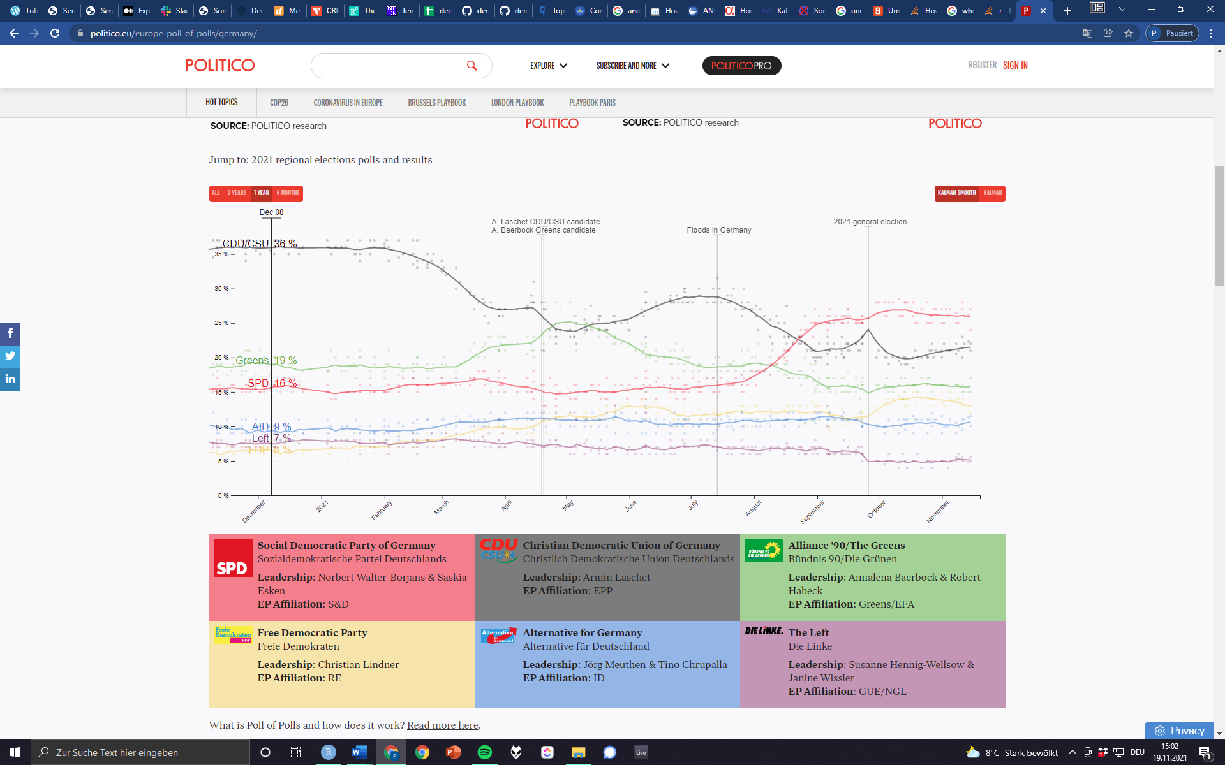

https://www.politico.eu/europe-poll-of-polls/germany/

Sources: